Table of Contents
Introduction To the System 1
1. User Requirements 1
2. Analysis Phase 2
3. Design 3
Pseudo-Code 3
Flowchart: 5
4. Implementation Phase: 7
5. Testing Phase: 9
Errors: 9
Troubleshooting: 10

Acknowledgement
We would like to express our sincere gratitude to our lecturer, Dr. Amer Abu Zaher for his invaluable guidance, continuous support, and constructive feedback throughout the development of this project. His expertise and insightful suggestions greatly helped us refine our work, improve our understanding of fundamental operating systems and programming concepts, and successfully completion of the Australian Open Ticket Management System (AOTMS).
We are also thankful for the opportunity to work on this assignment, which allowed us to apply theoretical knowledge to a practical implementation. The feedback provided at various stages helped us identify areas for improvement and enhance the functionality and robustness of our system.

Introduction To the System
Tennis Australia (TA) hosts the Australian Open (AO), an annual tennis tournament held at Melbourne Park in Victoria, Australia. The Australian Open Ticket Management System (AOTMS) is a user-friendly package of software that simplifies ticket purchasing and selling for the Australian Open 2026. The system caters to the range of needs of visitors with an effortless process of selecting, calculating, and purchasing tickets and obeying event-based rules and pricing structures.
AOTMS will try to combine compulsory aspects such as user authentication, concession validation, age differentiation, and ticket stock control to ensure that it is precise and fair in ticket distribution. The system supports diversified forms of tickets such as Ground Passes, Reserved Arena tickets, and special event tickets with dynamic price variations for children, youth, adults, and concession holders (e.g., students and pensioners).
By automated ticket management, AOTMS system seeks to enhance user experience, reduce administrative overhead, and ensure event policy adherence, making it an essential application for the Australian Open.

1. User Requirements
The Australian Open Ticket Management System (AOTMS) is instituted to ensure a smooth and efficient ticket purchasing process with due compliance with event-based requirements. The key requirements are user authentication, where users need to log in with valid credentials to access the system. The system is designed to verify login requests and display appropriate error messages for invalid information input, to ensure security and prevent unauthorized access.
The second key functionality is ticket price calculation that allows users to select from various categories of tickets such as Ground Passes, Youth Passes, and Reserved Arena tickets. The price is computed dynamically based on age groups such as children (3–11 years), youth (12–17 years), and adults (18 years and above), along with concession to students, pensioners, and other applicable groups. Furthermore, special ticket limitations are put on high-demand games like the Men's and Women's Finals to ensure balanced distribution. To prevent overselling and to keep things in line, the system enforces ticket purchase limits per session. As an example, a maximum of six tickets may be purchased for Rod Laver Arena finals. After selecting tickets, an order summary, such as the ticket type, age category, price, purchaser's name, and total price, is displayed to the user for transparency in the transaction.
Error handling is a key feature of the system that ensures user inputs such as age and tickets are validated, and explicit error messages are given for invalid inputs so that incorrect submissions are prevented. Furthermore, the system includes session-specific rules for both events at John Cain Arena (12–20 January) and AO Live (23–25 January) so that any purchase is aligned with the rules of these sessions.
By integrating these functionalities, the AOTMS provides a robust and user-friendly ticket sales management system for the Australian Open, enhancing customer satisfaction and business efficiency.

2. Analysis Phase
The AOTMS must categorizes tickets into different types, including Ground Passes and Reserved Arena tickets, with different price systems. The most crucial feature of the system is its age-based ticket price system, which changes ticket prices according to pre-specified age brackets: children (3–11 years old), youth (12–17 years old), and adults (18 years and above) and old people (over 60). Lastly, the system also features concession pricing for eligible groups such as students, pensioners and vice-versa, with verification to ensure only qualifying individuals receive discounted rates. To prevent overbooking as well as fair access, the system has stock limitations, capping tickets to be purchased per session, particularly for high-demand events such as the Men's Final, Men’s Semi-Final and Women's Finals.

Inputs and Outputs
The system processes multiple inputs to facilitate ticket transactions, including the buyer's name, ticket type, age, concession, and number. These inputs undergo rigorous validation to ensure data correctness before processing any transaction. Where successful validation occurs, the system generates outputs such as the calculated ticket price, detailed order summary, and validation messages to confirm the transaction or notify the user of errors.

Logic Flow and System Workflow
The AOTMS uses a rational sequence of structures to ensure that users have a seamless experience. The operation begins with a secure login, whereby the users authenticate their credentials to enter the system. Once they have logged in, the users can select their desired ticket type and quantity. The system then verifies the information provided, particularly the age of the user, to apply the appropriate prices rules. And when a concession is asserted, the system checks for eligibility prior to discounting. Lastly, an order summary is produced, summarizing all the transaction information for user verification and authorization.

3. Design
Design Phase is crucial element of system development. It is detailed blueprint of how the software will work. In this phase, it is ensured that product interface designs are user-centric and logical. It is all about converting requirements to system design, which takes place by creating documentation and assessing its functionality. There are 4 major workflows in the system. It would be user-authentication, age-concession, ticket inventory management and ticket processing. So, the step-by-step process of implementing those logic into the system is planned here.

Pseudo-Code
Pseudo-Code for Overall Flow of System:
1. Initialize GUI with login screen
2. IF user logs in successfully:
a. Display main menu
b. IF user selects "Calculate Ticket Price":
i. Show ticket selection interface
ii. Ask user to enter their name.
iii. FOR each ticket:
- User enters their name.
- User selects type, age, and concession status.
- Validate inputs (age, concession eligibility).
- Calculate price based on rules.
iii. Display order summary
c. IF user selects "Logout":
- Return to login screen
3. ELSE:
- Show error message for invalid login

PSEUDO-CODE for User-Authentication:
1. display login form (username, password fields)
2. on clicking login button:
a. gets username and password from input fields
b. if credentials match stored users:
i. redirect to main menu
c. else:
i. show "invalid credentials" error
3. on logout:
a. clear current user data
b. redirect to login screen

Pseudo-Code for Age concession:
1. calculate price based on entry of ticket type, age and concession type:
a. if age < 3: return 0
b. else if 3 <= age <= 11: return kids price
c. else if 12 <= age <= 17:
i. if youth ticket: return youth price.
ii. else: return concession price if has valid concession else standard price
d. else (age >= 18):
i. return concession price if valid concession else standard price
2. check concession validation with age and concession type:
a. if student card and age >= 30: reject
b. if pensioner card and age <= 60: reject
c. else: accept.

Pseudo-Code for Ticket Inventory Management:
1. check inventory with ticket types and quantities
2. display the remaining tickets for specific ticket type:
a. return current inventory for ticket type
3. update inventory for given ticket type with its quantity:
a. decreases the quantity from current inventory ticket type.
b. ensure value doesn't go below 0.
if ticket is 0, show error message of no tickets available.

Pseudo-Code for Ticket Processing:
1. on add ticket button click:
a. validate quantity <= remaining tickets
b. for each ticket in quantity:
i. creates age input field.
ii. create concession toggle (if eligible)
iii. store in ticket details list
2. on calculate total price button click:
a. validates all fields completed including name.
b. calculates total price using price calculator.
c. generate summary with:
i. customer name
ii. per-ticket details (type, age, price)
iii. total amount
d. update inventory

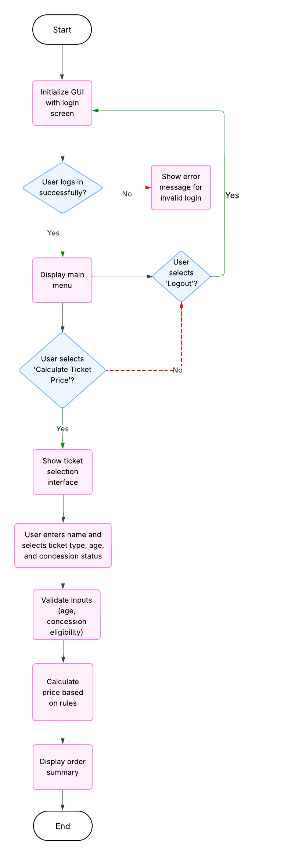
Flowchart:
Figure 1: System WorkFlow
Basic Menu Working:
Given figure explains how the system works, first a GUI menu
appears that asks user for login authentication. If user provides correct
login credentials, it will redirect to main menu otherwise shows an error
message for invalid login credentials.
When user is redirected to Main menu for ticket purchasing. He is
provided with option to select ticket type along with name of ticket’s
purchaser, age, and concession based on age. Furthermore, it would
validate the age input and whether the individual is eligible for concession
based on age and until then gives off warning message. When input provided
matches with the requirement, it would perform calculations based on input
age and concession then proceeds to display order summary.

Price Calculation Logic:
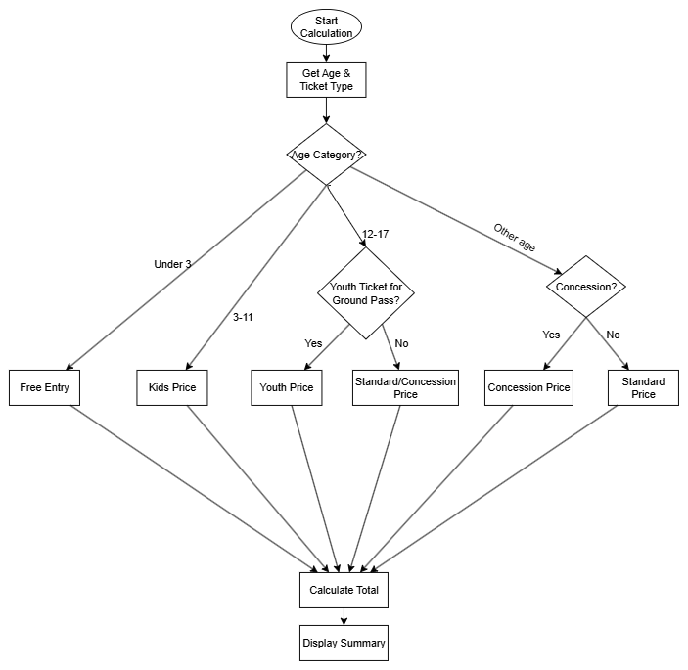
Figure 2: Age Concession Workflow

The flowchart illustrates the logic of calculating ticket prices in the Australian Open Ticket Management System (AOTMS). The process begins when a user selects a ticket type and enters his or her age. The system first calculates the age category to determine the pricing level. Children under 3 years are provided with free entry, and those aged 3–11 receive the child price. For age range 12–17, the system also checks if the ticket selected is a Youth Ground Pass, for which a fixed youth price is available. Otherwise, the user can still be eligible for concession pricing if they possess valid proof (e.g., student card). Adults aged above 18 years are redirected to a concession check, where prices are reduced if they meet eligibility criteria (e.g., pensioners or students under age 30). If there is no concession available, the normal price is considered. Once all the tickets are processed, the system calculates the total price and displays a summary along with the price details of each ticket and the total price to be paid.

4. Implementation Phase:
Login Attempt:
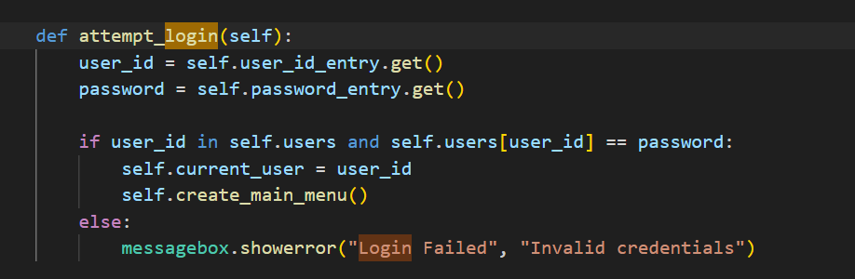
Given figure has the code that handles user authentication of the Australian Open Ticket Management System. This takes the user input when the user submits their credentials and checks it against the stored user data (self.users). It logs the user in and displays the main menu by calling self.create_main_menu() if the username and password match. The user is shown an error message using messagebox.showerror() if the credentials do not match. This will make the system only accessed by the authorized users, maintaining security, and preventing unauthorized access. The self.current_user variable contains the current user who is logged in, allowing session handling throughout the application.
Ticket Price Calculation Logic:
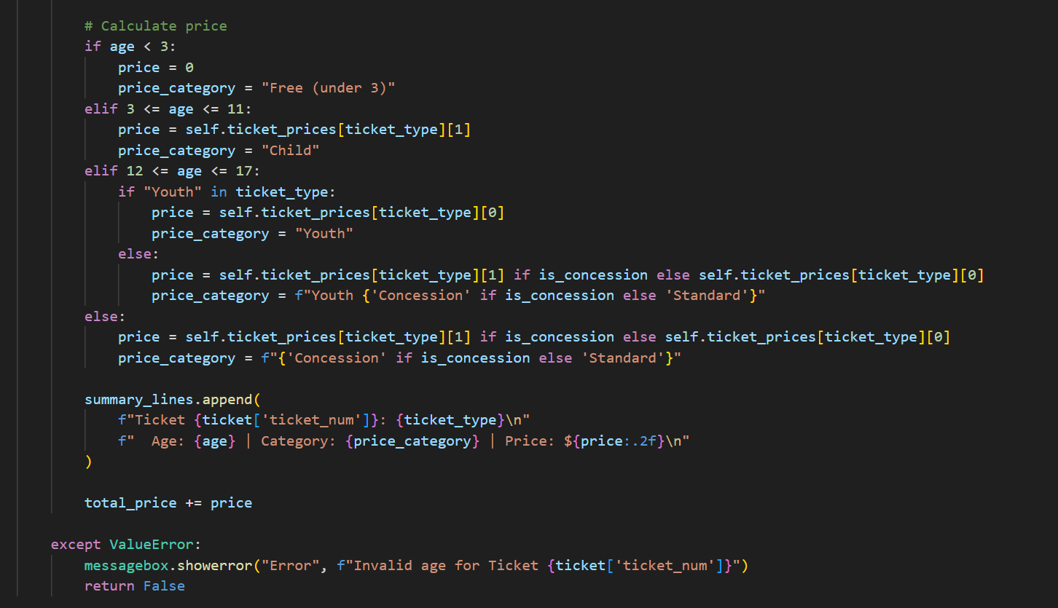
The figure above represents ticket price logic that calculates the price dynamically based on customer age and concession status. Children under 3 years are provided with free tickets, and for children between 3 and 11 years, concession price is applied. Special "Youth" tickets of fixed price are applicable for 12–17 years, and regular tickets offer concession discounts if qualified. Adults over 18 years receive standard, or concession pricing based on qualification. The program categorizes every ticket type (e.g., "Child," "Youth Concession," or "Standard") and appends the information to a summary list. An error message appears when an incorrect age is utilized to enforce correct pricing before finalizing the purchase.
Inventory Management:
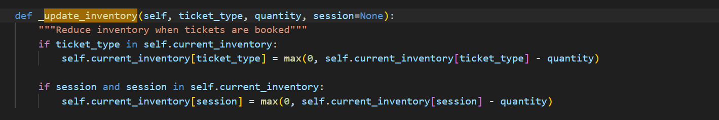
Given figure explain how _update_inventory method approach ensures real-time tracking of available tickets by subtracting quantities purchased from stock. It checks if the session type exists in self.current_inventory and reduces it similarly, preventing negative quantity. It also separately updates session-based stock for special events like Rod Laver Arena final sessions. This prevents overbooking and maintains correct levels of stock for different types of tickets and events. The process is invoked only after valid validation to ensure updates of the inventory represent validated purchases.

Summary Generation:
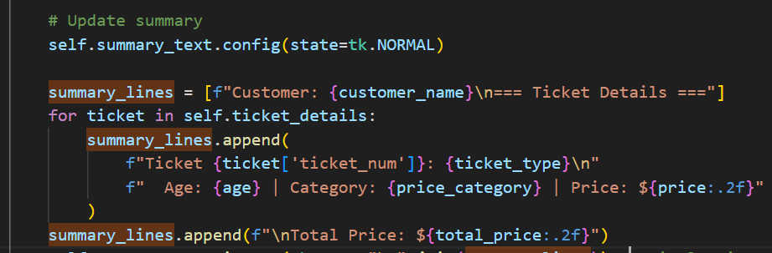
After ticket validation, the system generates a detailed receipt for the purchase. The customer's name is at the top, followed by individual ticket details (type, age group, and price). Each ticket price is styled neatly, and the total price is calculated and included at the end. This functionality improves customer experience as it gives a clear breakdown of charges and allows customers to see their order prior to finalization.

5. Testing Phase:

Errors:
Ticket Inventory Update:
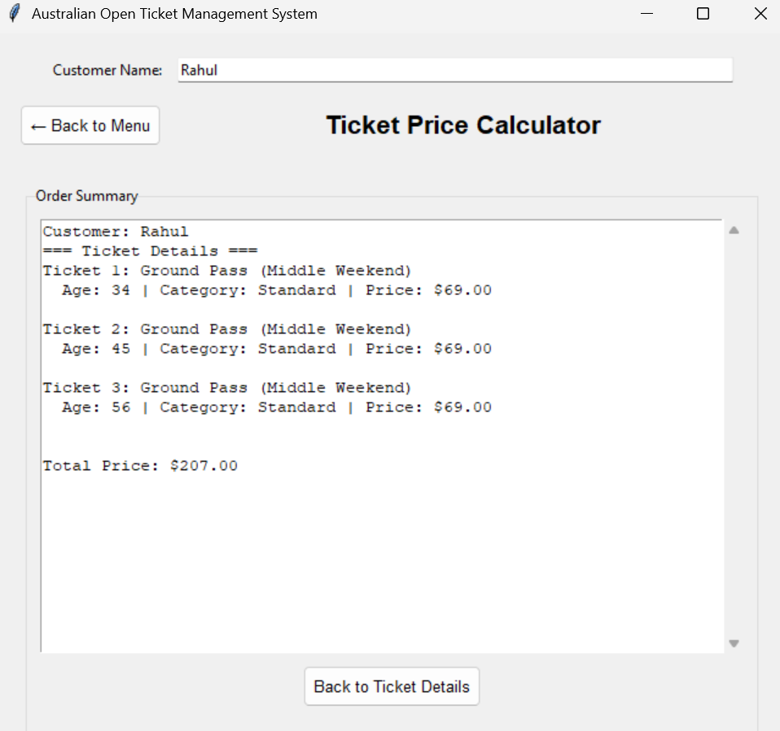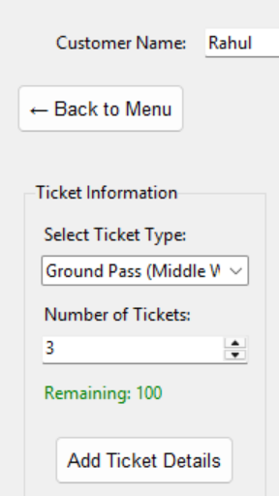
Even after ticket purchased, the remaining ticket counter is 100. This had to dropped by 3 and tell 97. This was fixed too.

Caching Old Ticket Detail:
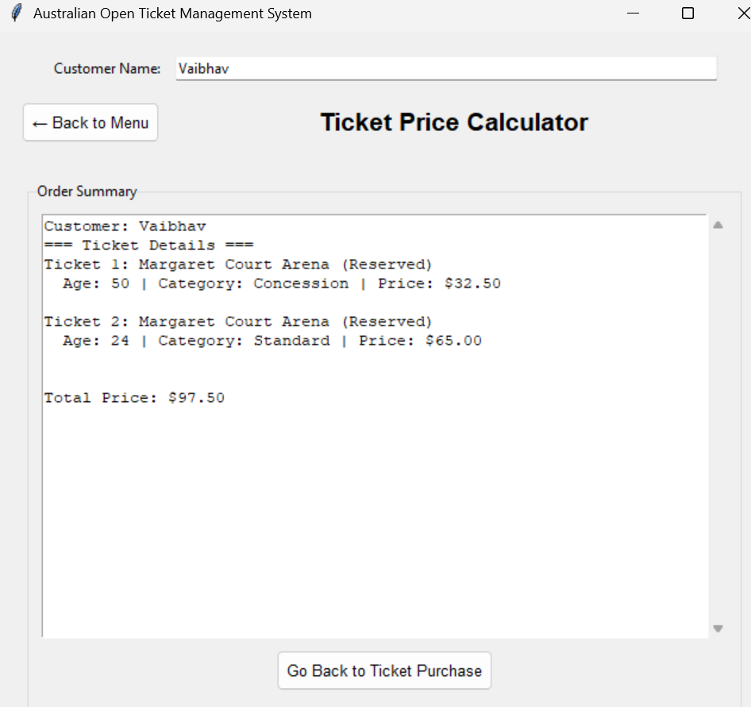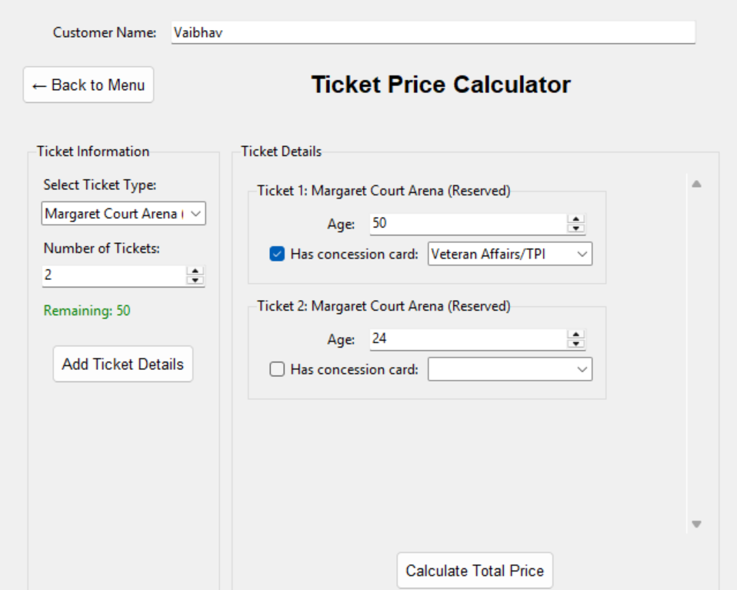
After purchasing of ticket and going back to ticket purchase, the detail of old tickets was still there. It was fixed.

Troubleshooting:
Ticket Inventory Updated Solved:
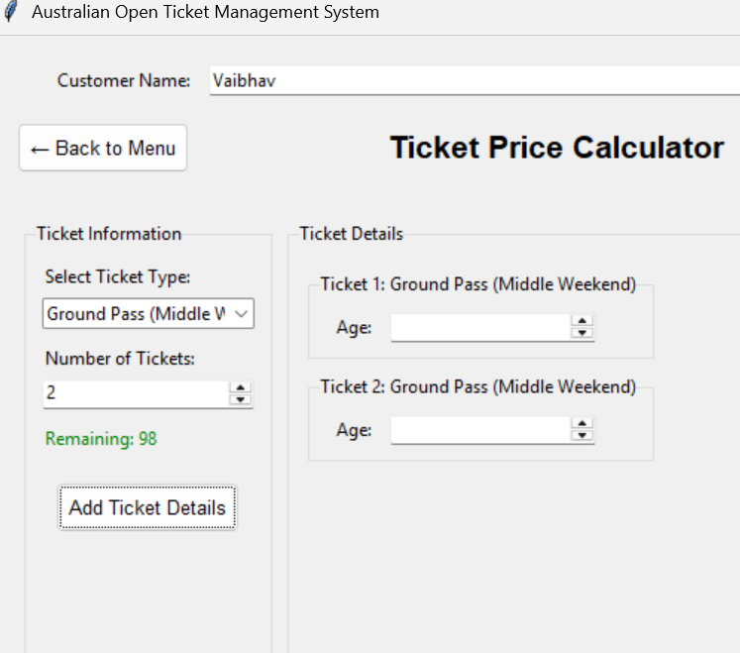
Now, when ticket is purchased, the inventory stock for ticket gets updated.

Old Ticket Detail Caching Problem Solved:
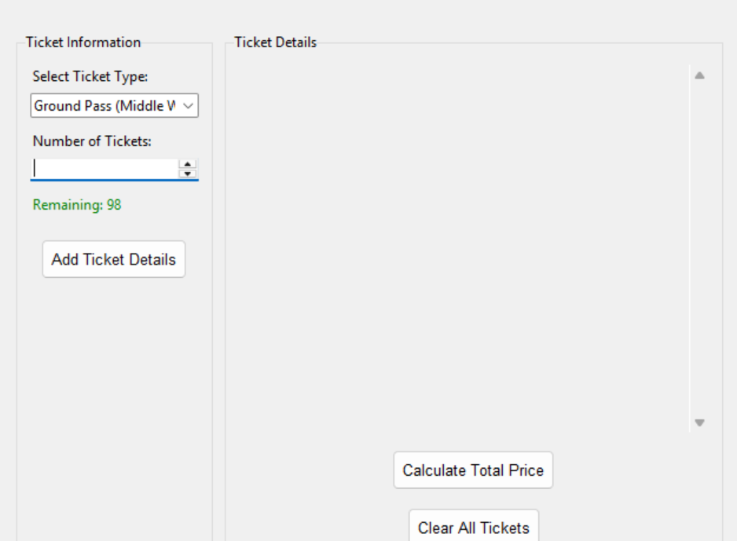
Now, when user gets back to put new detail for ticket, the previous detail is removed.

Test Case:
Test Case | Input | Expected Output | Output | Remark
Login Successful | Correct Username/Password | Must direct to menu | Directed to the menu | Successful
Invalid Login Attempt | Wrong Username/Password | Provide Error Message | Gives Error message | Successful
Rod Laver Arena Ticket | Special Occasion Type and Limited Ticket Number | Ticket Inventory decreased and print of summary | Summary of ticket and ticket inventory updated. | Successful but always need to click on occasion type and then get ticket detail to see update
Adding Valid Concession | Let Age= 65 and concession “pension” | summary with concession price | Get Ticket summary with concession price | Successful
Invalid Concession | Age= 40 and  Concession = “student” | “Concession can’t execute” | Ticket not added, warning given | Successful
Youth Ticket Invalid Age | Age = 40 | doesn’t allow ticket | Warning and no ticket allowed | Successful
Session Sold Out Ticket | Ticket Detail | Warning for no tickets available | Warning message for no ticket’s availability | Successful
AO Live Date Validation | Wrong Date = 30 | Error Message | Error Message of no ticket available for such date. | Successful
Ticket Depletion  (When 1 ticket is available for event) | Enter 2 tickets | Error Message | Only 1 ticket available for given event. | Successful
Logging Out | Click Log Out | Must exit | Exit to Login system | Successful

Appendix:
